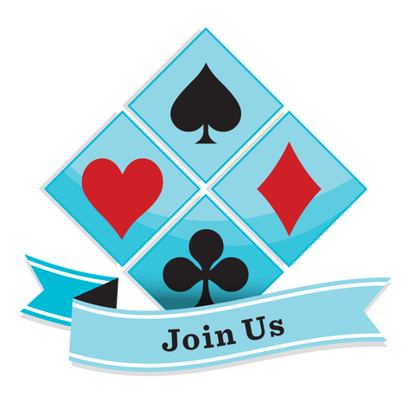
Spokane ACBL Unit 448 invites you to our
Labor Day Sectional
September 2, 3, 4 and 5
PLEASE NOTE: Proof of COVID 19 vaccination required (Additional $4 for unpaid ACBL members)
All events held at Spokane Bridge Center 1427 North Argonne Rd, Spokane, WA 99212
Plenty of free parking; complimentary coffee & refreshments – Scholarship Funds Available, contact
Tami Gillman 206 619 6844

Friday September 2nd $15 per session 11:00 a.m Stratified Pairs – One Session 4:00 p.m. Stratified IMP Pairs – One Session

Saturday September 3rd $15 per session
10:00 a.m. Stratified Pairs – First Session
3:00 p.m. Stratified Pairs – Second Session
(Single session entries available

Sunday September 4th $15 per session
10:00 a.m. Stratified Pairs – First Session
3:00 p.m. Stratified Pairs – Second Session

Monday September 5th^{h} $120 per team
10:00 a.m. Stratified Swiss Teams (VP scoring)
Two Session Play – Through Short Lunch Break

Lunch included in Swiss Team Event
7-8 Board Matches Strata: 0-500, 500-1500, 1500+
By Total Average: Pair/Team

Intermediate/Newcomer (if enough tables)
Friday September 2nd
11:00 a.m. Stratified Pairs-One Session
4:00 p.m. Stratified Pairs – One Session
Saturday September 3rd
10:00 a.m. Stratified Pairs – One Session
3:00 p.m. Stratified Pairs – One Session

Tournament Chair
Tami Gillman
Tami.gillman@gmail.com
206 619 6844
Partnership Chair
Pat Gorton
509 990 8558
dpsgorton@msn.com
Sanction Number - 2209354
Spokane Bridge Unit 448
Director in Charge – Jenni Carmichael

Discounted Rooms (Ck Cancellation policy)
Fairfield Inn & Suites by Marriott
8923 East Mission Avenue
Spokane Valley, WA 99212
Call 509.928.5218 for reservations
Rate reserved till July 31st
Ask for Spokane Bridge Center rate $159/night
