SBU Board Meeting Agenda
  - Meeting date: March 8, 2021, at 5:00 p.m., via Zoom teleconference
Zoom details:
https://zoom.us/j/97601883354?pwd=QTgyMmxaSXNFaHp4RC9FVHpPOUJzZz09
Meeting ID: 976 0188 3354, Passcode: 1430
Board members in attendance:
Board members absent:
Also present:
Board members indicated with an * joined the meeting late and were not present for asterisked votes.

Review Action Items

Actions on Hold
Action | Assigned To
Consider possible increase in entry fee for Unit tournaments. | Deferred until after it is known when sectional can resume

Status of Continuing Actions
Action | Assigned To | Update
Inspect trailer and its contents for possible damage. | David D | (At last meeting, there was some comm with Roger, any update since then?)
Committee appointed to review Bylaws for possible changes. | JC (as committee chair) | Had first meeting on 2/27

Status of February Actions
Action | Assigned To | Update
Find and hire director for Sweetheart Swiss virtual event | Ann | Complete
Set up unit on RealBridge | Jeff | Complete
Obtain and send to hospitality + membership the list of members not currently on BBO | JC | Complete
Establish mentoring sign-up for inclusion in the welcome packet | Ann | ??
Propose virtual tournament schedule for rest of year, following Sweetheart Weekend | Jeff | On agenda to postmortem Sweetheart
Continue effort to draft and finalize a Welcome Packet, analyze in/out report, and make recommendations to excite players | Hospitality Committee | ??

Agenda

Approval of meeting minutes

Treasurer’s report

District 19 Representative
One candidate submitted – Ann Romeo, who will speak about her candidacy and answer questions.
Board vote on representative planned.

Review Membership Data
JC & David to present. (See appendix for some data charts)

ACBL Announcement Regarding Tournaments
Discuss ACBL announcement allowing tournaments to resume in the fall. (Input from F2F Play Committee appreciated!)

Sweetheart Weekend Tournament Postmortem
Jeff, Scott, Ann, JC to discuss

Additional Virtual Tournaments & Unit Games
- Proposals for dates, content from Jeff, Scott, Ann, and David for Virtual Tournaments
- Planning for Round Robin, any other unit games
  - Continuing Action: Consider changes to the Round Robin format to allow flights to be maintained regardless of the number of sign-ups.

Review Draft Welcome Letter
Karen & Tom to review with the board a draft welcome letter to new members. Draft text below:
DRAFT WELCOME LETTER

Date:
Dear Xxxxxxx,
Welcome!
We have been informed by the ACBL that you recently became a member of ACBL Unit #446 which encompasses the greater Seattle metro area.
Whether you are new to bridge, new to the ACBL, or simply transferring from another Unit, we would like to extend a whole-hearted welcome and send you some information about Unit #446. The unit website at: http://www.bridgeinseattle.org/ will provide you with a comprehensive summary of available clubs,newsletters, and other Unit #446 activities.
While all of our games are currently virtual, you can literally find a bridge game in Seattle any day of the week and usually either during the day or in the evening.
Finding partners can often be the most frustrating thing for new members. We think that you will find our club managers very responsive to helping you find a partner, and we too as a Board are committed to enhancing that process.
Please feel free to reach out to anyone on the Board (e-mails included on website), or more specifically to the below signed Board member.
We look forward to seeing you at the table, both virtually and (hopefully in the not-so-distant future) at one of the clubs!
Regards,
ACBL Unit 446 Board and
Specifically: Board Member Name: boardmember e-mail

Next Meeting
Proposed date Monday, April 5th at 5pmPT via Zoom

New Business

Appendix – membership data charts

JC’s Mega Table (work in progress)

Heat Map of Player Locations (by Joseph Grill)
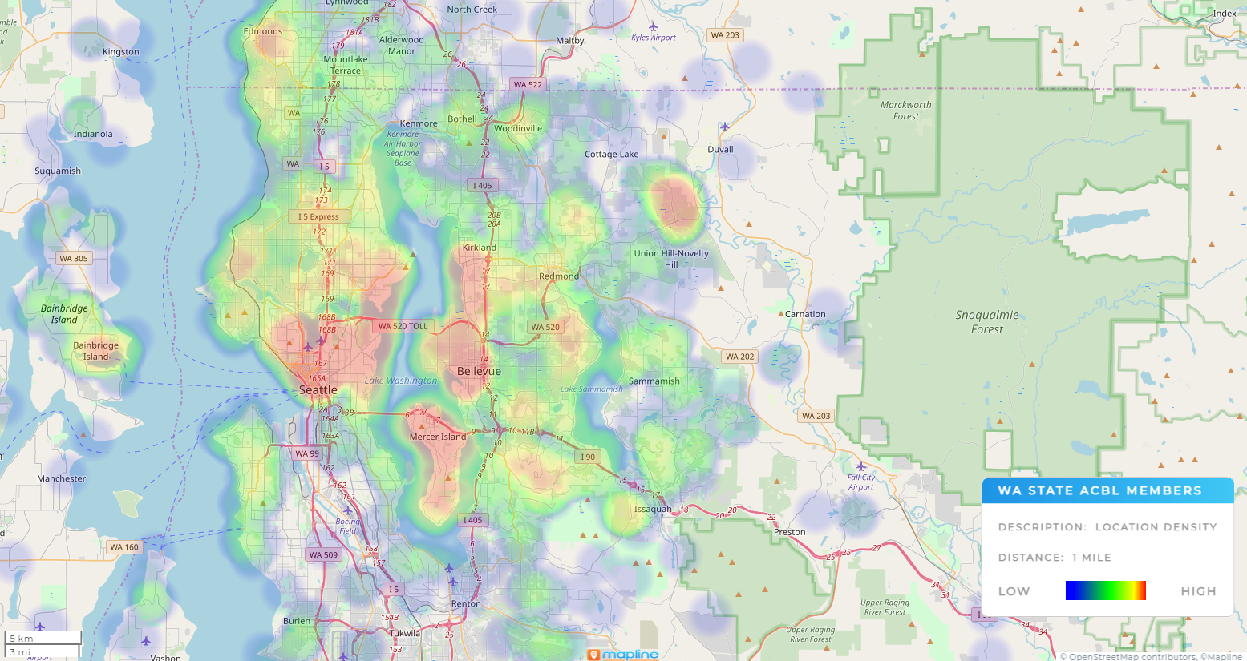

Unit Player Counts by Rank Over Time (by David Dailey)
