Toronto – 2017 Summer NABC Wrap Up

Thank you to everyone who attended the Summer NABC in the beautiful city of Toronto. We were fortunate to have nearly perfect weather, a world-class venue and a highly experienced staff to support our members in the game of bridge at the world’s highest levels.

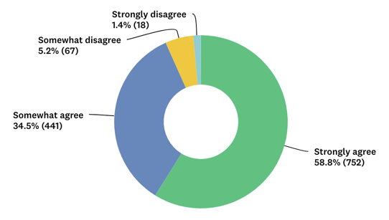
We asked all the attendees to complete a survey to help us make this event even better in the months and years ahead. Thank you to the nearly 1300 members that took the time to share their valued opinions with our team. We take this feedback seriously and appreciate your thoughts.

The results of the survey were overwhelmingly positive. Nearly everyone loved Toronto, the Metro Toronto Convention Center, the tournament directors, the hotels and the overall experience. Still as wonderful as the results were, there is room for improvement.
“My overall experience at the Toronto NABC was excellent.”

Below is a simple breakdown.

NABC by the Numbers

Over the course of 10 days, more than 6000 players attended the Summer NABC (nearly 3100 from the U.S. and about 2600 from Canada). This led to an impressive 13,289 tables. While in Toronto, bridge players drank 40,000 cups of coffee to keep their energy up and ate at some of the 132 restaurants featured in the NABC’s Restaurant Guide. Many players stayed at the host hotel, which meant 12,621 rooms were sold.

The Youth NABC always coincides with the Summer NABC, and this year a record-high 242 players (age 19 and under) came to the three-day event. The Collegiate Bridge Bowl was also held, and eight teams – a total of 37 players – participated.

Successes and Opportunities for Improvement

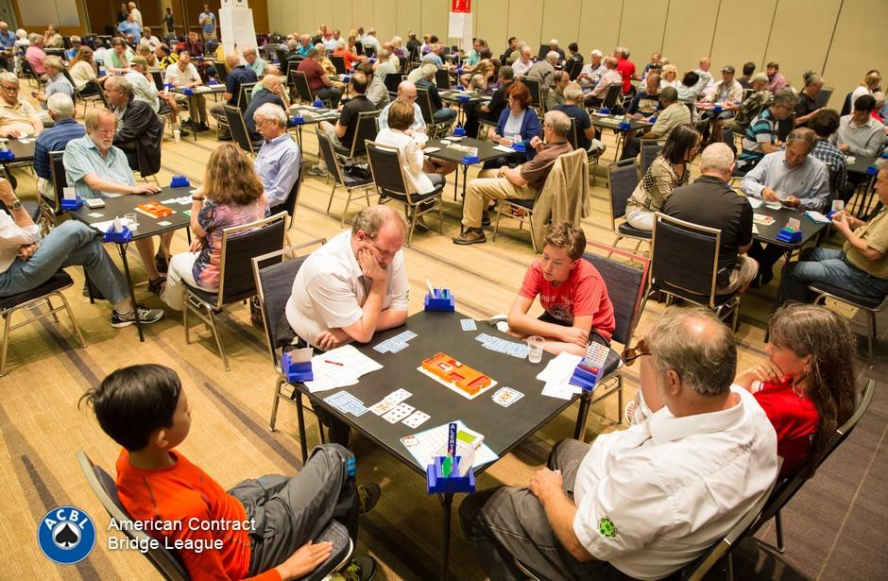
The location was by far one of the most-liked facets of the Toronto NABC. Some of members’ other favorite parts were the quality of the facility, the “camaraderie” of the tournament and “meeting so many people from all over the world.”

There is still room for improvement, and we’re listening to your suggestions. The most common complaints were poor signage, too few directors and a need for “a better registration gift and better hospitality.”

Many members expressed frustration with the availability of hotel rooms. We are working to address the issue and recently implemented a hotel cancellation policy for the 2017 Fall NABC. Members will be charged a fee (separate from charges that may be imposed by the hotel) to try to discourage players from making reservations and canceling at the last minute.

Another improvement we will be attempting to incorporate in the future is the ability to pay for entries with a credit card. This was recently tested at a regional tournament in Mississippi.
NABC Online Individual Tournament

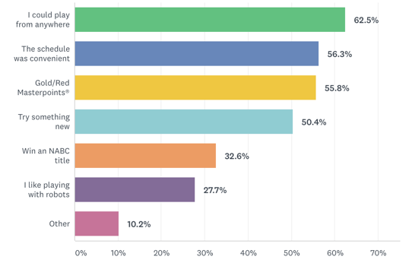
Toronto “hosted” the first online NABC game, powered by Bridge Base Online. This four-day experimental event attracted more than 2500 ACBL members. Each player partnered with a BBO robot to compete for awarded red and gold points.

More than 1000 participants provided feedback about the event. Overall, members felt that registering and playing in this event was easy. Players also agreed that the allotted time (up to four hours) for playing the 24 boards for each session was plenty. Reasons for participation vary, but clearly location and schedule flexibility were at the top. Players are also interested in novelty game formats.

Many members recommended to stratify future events to improve the chances of less experienced players to score masterpoints.

See you in San Diego for the Fall NABC!

