Thanks for your feedback

Thirty three of the fifty-six members of our Headquarters staff responded to the survey we sent the week of September 25th. This is enough input that I feel we can believe that those who responded fairly represented the views of this group.
Many outside of HQ may be surprised by the response to the first question. You seem to believe that we don’t need more folks with strong bridge skills. (This choice came in 8th out of 10 qualities we should seek!). Instead, you felt we should try to bring in skills we don’t have, people who are hard-working, and those who are good communicators.
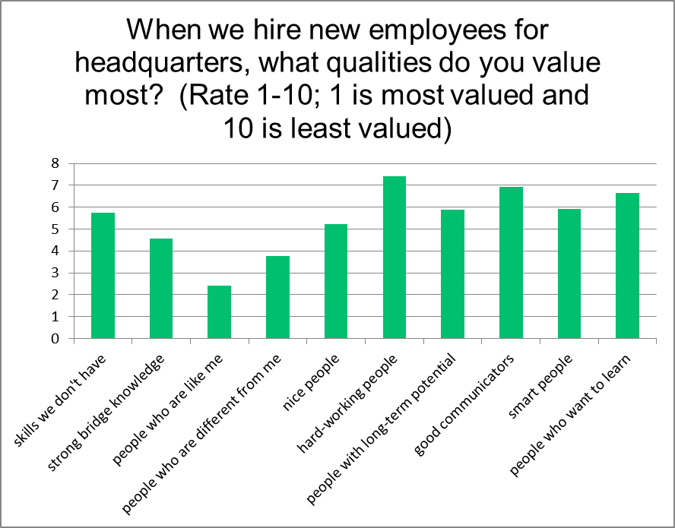
I am concerned about one response. While you didn’t necessarily want people who “are like me,” you also didn’t seek to bring in people who are “different from me.” I’d like to encourage all of you to keep an open mind if we are interviewing potential additions to our group. Be willing to accept “strangers” who don’t necessarily know our norms and culture. Doing so will help us get the skills we don’t have, smart people, and other choices you gave higher ranks to.
You told us that you’d like the environment here in Horn Lake better if communication flowed more smoothly through our office. Reading the comments you added makes clear that you would like less of the communication via meetings—or you’d like any meetings to have a clear direction.
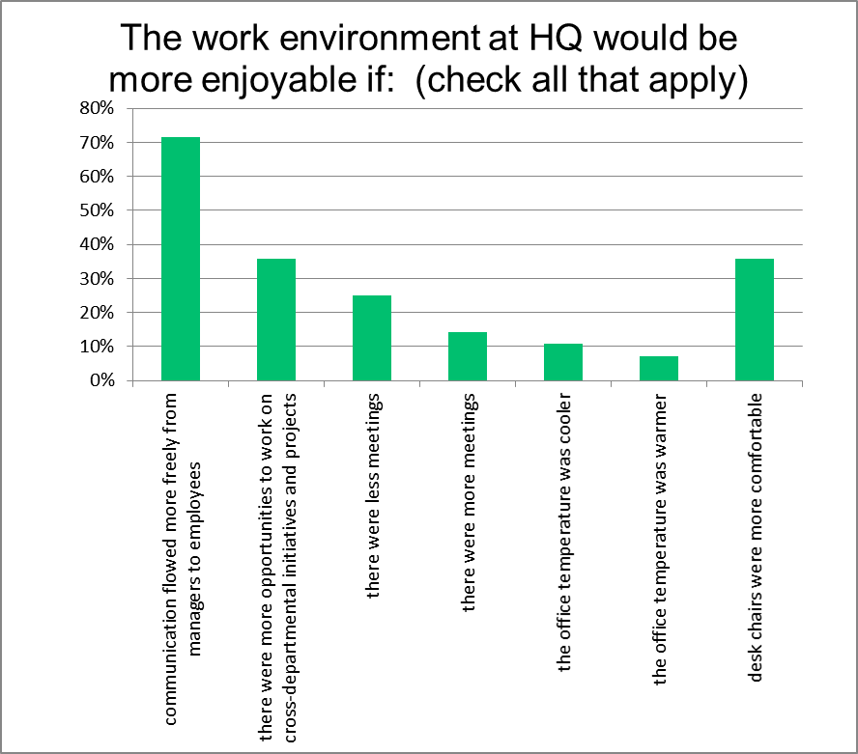
As you may know (although we may not have communicated it “freely”!), we have begun a review of our office ergonomics. In the course of this study, I hope we can address issues such as uncomfortable chairs and the office temperature. We also have a lot of projects underway—many of which will require cross-department cooperation.
The final question dealt with a set of proposals we gave the Board in September. These got the title “Big Ideas,” although as several of you pointed out they are not necessarily that big (or that new). 29 of you said you’d heard about these ideas. I’m disappointed that you haven’t all heard about them and also by comments that indicated you didn’t hear about them from your manager. Our executive team was supposed to share the ideas within their departments. I know it happened in some areas—we apparently didn’t get this 100% right.
The most popular idea seems to be advertising and promoting bridge. This is the same idea that is most popular with our members (we sent the ideas to all ACBL members, as well). You also liked simplifying masterpoints (makes sense since we take the brunt of the current confusing situation) and improving teaching results.
Are there other things we should have asked about? Please share ideas for future surveys with me or with Nancy. We have a lot of plans in progress and a lot of things to work on for the rest of this year. I hope you will continue to give me feedback and advice about how to make ACBL more effective in any way you wish—either directly when you see me in the hall or via your manager.

