Improve Teaching Results

Current Situation
- About 1,600 teachers are registered in ACBL’s online teacher directory (these teachers opted to be listed, after receiving at least one accreditation).
- ACBL has about 7,000 accredited teachers in its database, some with multiple accreditations:
  - ACBL TAP 6,704
  - Better Bridge Teachers 1,051
  - ABTA Teachers 702
  - Easybridge! Presenters 1,058
  - LBIAD Accreditation 214
  - ABTA Master Teacher 88
- Many teachers do not encourage students to play at clubs and tournaments, or join ACBL. However, about 76% of ACBL’s rookie members (0-5 MPs) attended some bridge lessons
- Teachers determine their own curriculum and method to follow
- Some teachers are associated with a club—others are not
- ACBL spends about $12k per year in recruitment incentives for teachers and clubs
- ACBL spent about $8k in 2016 to accredit 163 teachers (NABC and Regional TAPs). It hosts three morning sessions at each NABC for teacher training and employs one full-time employee to liaise with teachers.
- Many teacher may not “report” their activities (and so aren’t counted in the stastics above). Some teachers focus on coaching intermediate and advanced players and so do not contribute a lot of new members.

Problems
- ACBL-accredited teachers train an estimated 30,000 students per year. Only 5,000 to 6,000 of these (average for the past three years) become ACBL members. Only 4,692 (40%) of the 11,741 members recruited in 2013 and 2014 are still members at this point in 2017. While 3,429 of these students (29%) have won at least some masterpoints to date, only 96 (less than 1%) have won points during the first 8 months of 2017. The students-signed-up to teacher ratio of 5,000/7,000 is low. The “conversion rate” from student to active ACBL member of under one percent is extremely low.
- No metrics show how effective teachers are at improving player skills. No metrics show that teachers effectively motivate new and existing players to play more frequently, and go to clubs and tournaments. See attached evidence drawn from ACBL data sets.
- There is no standard for evaluating and ranking teachers:
  - Each accreditation program has its own test for graduation.
  - There is disagreement on the correct measure of teacher performance (e.g., subsequent social play, play in clubs, play in tournaments, winning masterpoints).
- Teachers don’t share a common curriculum. Many teaching materials are outdated:
  - They exclude newer bidding techniques
  - They are not engaging and relevant (example is an over-emphasis on bidding instead of play)
  - They do not take advantage of e-learning opportunities.
- ACBL offers (and charges for) a Teacher Accreditation Program (TAP). This program is out of date and it is unclear if its requirements actually fit the teaching market’s needs.
- The only “master teacher” program (system for teaching bridge teachers) is controlled by the ABTA (American Bridge Teachers Association). It is not clear that this program is consistent with TAP and that these master teachers are being used effectively to improve teaching quality.

Solutions
- Research teaching effectiveness. Three possible, non-exclusive approaches:
  - Statistical analysis: track and measure how different teaching methods correlate with students’ game activity
  - Pedagogical Methodology: evaluate teacher and student materials based on current educational techniques, research and best practices
  - Teaching Techniques: investigate how modern classroom best practices can help bridge teachers increase student interest, engagement and performance.
- This research would be supervised by ACBL. Statistical analysis work could be done by ACBL staff. Pedagogical studies and in-classroom observation of teaching techniques would be done by outside partners.
- Encourage sharing of ideas or, if required, cross-licensing of curricula and content.

Implementation
- Based on the results of this research, document best practice for bridge teaching. Ask those involved in the existing systems to integrate ACBL’s findings into their system.
- Rebuild TAP. Integrate ACBL’s documented best practice approach into TAP. Require all existing TAP holders to re-certify over a reasonable time period.
- Develop effective incentives for teachers to sign students up as ACBL members:
  - Require anyone who holds TAP to sign up all students as trial ACBL members. Reduce cost of trial membership as low as possible ($5-$7?).
  - Pay teachers a substantial commission (up to half of first year membership payment) if their students elect to become full members of ACBL.
  - Consider paying additional bonuses if players renew their membership.
  - Consider paying additional bonuses to teachers if their students participate in club play and/or tournament play.
- Improve the web site teacher referral system. Site should list class location and times. Show the association between teachers and the clubs they work with. Publish teacher statistics (number of students trained, average club play and tournament play performance of students) for teachers. Consider setting up a Yelp-style review opportunity for students.
- Partner with the ABTA or other organizations to develop a method of evaluating a player’s level of performance. This will allow improved long-term tracking of teaching methods.
- Partner with one or more educational course providers and shift administration of TAP to these outside firms.
- Involve the Educational Foundation in this project.

Funding
- Research--$150K
  - Statistical analysis:
    - Collaborate with ABTA and teachers to define teaching factors to track (number of lessons, location, textbook method, lecture vs. play time, etc.)
    - identify participating teachers and clubs
    - Measure students’ game activity at clubs, tournaments and social events (new CRM system and improved ability to capture game activity are key requirements)
  - Pedagogical Methodology and Teaching Techniques: either project will require to be outsourced to a specialized educational research vendor
- Update of materials--$50K
  - Revise TAP.
  - Update basic learning guide (acquire rights to redistribute an existing guide).
- Some funding may come from Educational Foundation. We may also be able to involve one or more educational institutions either as funding sources or as vehicles for administering the revised TAP.

Some Statistics
While we do not have meaningful data about teacher’s intrinsic performance (number of students, quality of teaching), we have some data about teachers and their ACBL member recruitment performance.
A few teachers are strong recruiters. Most teachers are not: In the last 5 years, about 25,000 new members were recruited by 2,900 teachers. The top 21 teachers recruited as many students as the bottom 2,170 teachers:
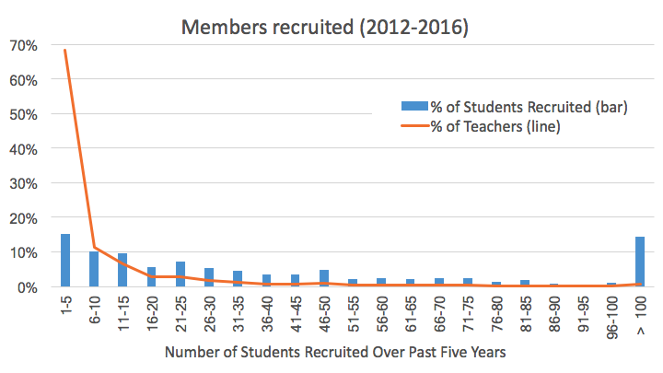
Average member recruitment, by teacher’s tenure with ACBL: Our data shows that teacher’s tenure as ACBL member doesn’t seem to affect their recruitment performance, specially for teachers who have been members over 10 years:
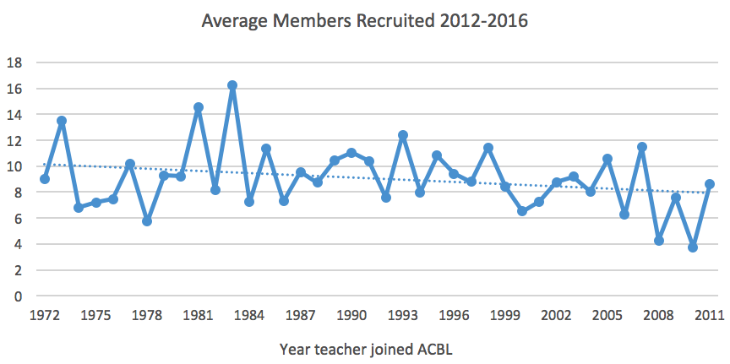

Average member recruitment, by teacher’s district: Recruitment varies among districts. It is uncertain whether this is caused by uneven potential (“Districts with larger cities can attract more members?”), or to differences in teaching programs or higher focus in duplicate bridge:
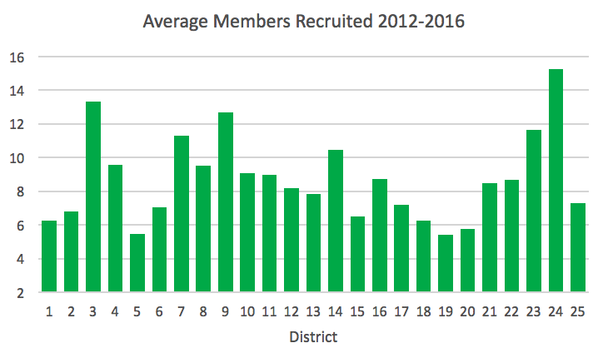
Average recruited member’s MP accrual, by teacher’s recruitment performance level: while teachers who recruit less seem to produce new members who win more MPs, the difference is very small:
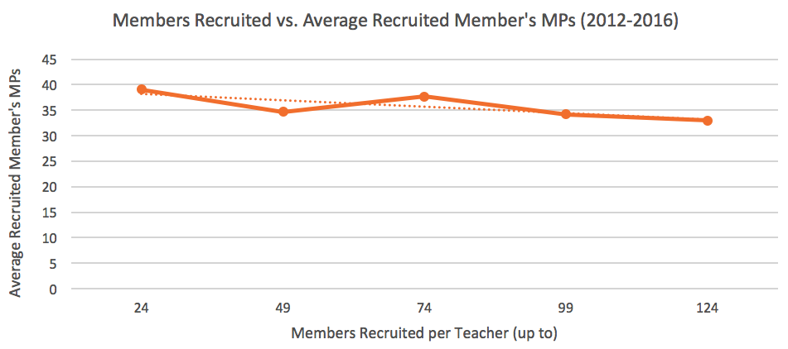

Rate of recruited members who play in tournaments, by teacher’s recruitment performance level: The teacher’s recruiting performance does not seem to affect the recruited members’ (students) interest in tournaments:


