Unit News Email Campaign Results
All results were recorded at 7 days following the send.
 | April | May | July | % inc/dec
Recipients | 1159 | 1160 | 1158 | -0.2%
Open Rate | 44.0% | 48.3% | 48.9% | 1.2%
Click Rate | 4.5% | 6.3% | 11.4% | 81.0%
Unsubscribes | 0.8% | 0.3% | 0.3% | 33.6%
Bounces | 1.8% | 0.4% | 0.3% | -39.9%
Most Clicked Link | NLM Sectional | Newsletter | Newsletter
Most Clicked Link Position | 1st/4th | 3rd | 1st

Printing Costs Summary

By Tournament (to date)
 | Clubs | Events | Total Copies | Total Cost | eCPP | Notes
Sweetheart Sectional | 200 | 75 | 275 | $175.66 | $0.64 | Printed first 200 in color (didn't know that wasn't standard); Did some of these 2-sided with the Spring NLM on back so technically shared
2016 Schedule | 400 | 600 | 1000 | $97.60 | $0.10 | went to mult. Sectionals
Spring NLM | 400 | 600 | 1000 | $108.51 | $0.11 | went to mult. Sectionals
KO Sectional | 400 | 600 | 1000 | $108.51 | $0.11 | went to mult. Sectionals
Suntan Sectional | 500 |  | 500 | $83.52 | $0.17 | 2-sided flyer
Fall Sectional | 300 | 410 | 710 | $98.06 | $0.14 | Did 10 "signs" in color, rest in greyscale
Fall NLM | 300 | 410 | 710 | $98.06 | $0.14 | Did 10 "signs" in color, rest in greyscale
Total | 2500 | 2695 | 5195 | $769.92

By Need Area (as reported)
Note that this does not align with how much we’ve been printing. This is the result of asking all the club managers how much they need.
Note that this suggests we need *more* newsletters, not less. We currently pay $517.25 per newsletter mailing for 200 copies, 6 times a year.
Est'd Cost Per Flyer/Newsletter | $0.11 | greyscale, 1 side | $0.11 | greyscale, 1 side | $2.59 | min. print 200, includes S&H
Club/Event | Gen. Sectional Flyers |  | NLM Event Flyers |  | Newsletters
Des Moines BC | 0 | $0.00 | 0 | $0.00 | 0 | $0.00
Eastside BC | 50 | $5.50 | 50 | $5.50 | 20 | $51.80
Mercer Island | 20 | $2.20 | 20 | $2.20 | 20 | $51.80
Mercercrest | 30 | $3.30 | 10 | $1.10 | 15 | $38.85
Nick's Distro (Alki, SBC, Rainbow, Everett) | 150 | $16.50 | 150 | $16.50 | 50 | $129.50
Patti's Clubs (Broadmoor, Overlake, Sandpoint, STC, Womens Univ) | 100 | $11.00 | 100 | $11.00 | 100 | $259.00
UW BC | 10 | $1.10 | 15 | $1.65 | 10 | $25.90
Vashon BC | 2 | $0.22 | 2 | $0.22 | 0 | $0.00
Per Sectional (can be more than one per flyer print) | 500 | $55.00 | 500 | $55.00 | 0 | $0.00
Mailed to Unit Members |  |  |  |  | 52 | $134.68
Total | 862 | $94.82 | 847 | $93.17 | 267 | $691.53

Tournaments Survey Topline (to date)
For the tournaments committee, we sent a survey out to the email list for the unit and also promoted the survey through paper flyers distributed at the Suntan Sectional. We are gradually distributing flyers to clubs as well and intend to keep the survey open through the end of August. The survey randomized the order of choices whenever logical/reasonable to do so.
Note that this topline will speak in the past tense for readability/clarity, even though the survey is still going on.

Email Distribution Results
 | Initial Email (7/14) | Reminder (7/28)
Recipients | 1153 | 964
Open Rate | 45.9% | 48.9%
Click Rate | 15.4% | 11.4%

Response Rate/Demographics
As of 8/8, 192 responses have been received (16% of unit). Of the responses received, 47% (91) have 500 masterpoints or less, compared with 68% of our unit. On the other end of the spectrum, 19% (37) of respondents have 2000+ points versus just 9% of our unit. Thus, we are slightly under-represented for newer players and 2X over-represented for experienced players.
Below is a breakdown of the masterpoint ranges of responses (based on responder’s reported total):
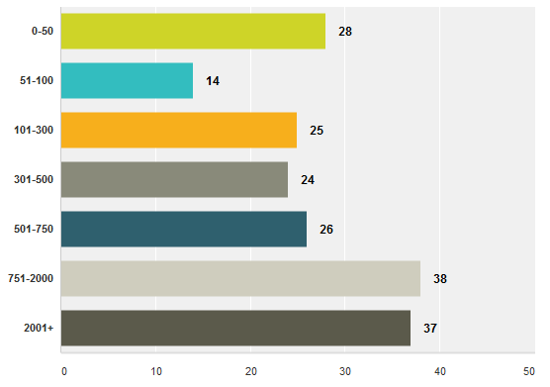
Most respondents have been to at least one tournament at some level in the past 3 years; only 9 respondents had not been to a tournament of any type (5%) and only 15 respondents had never been to a sectional (8%).
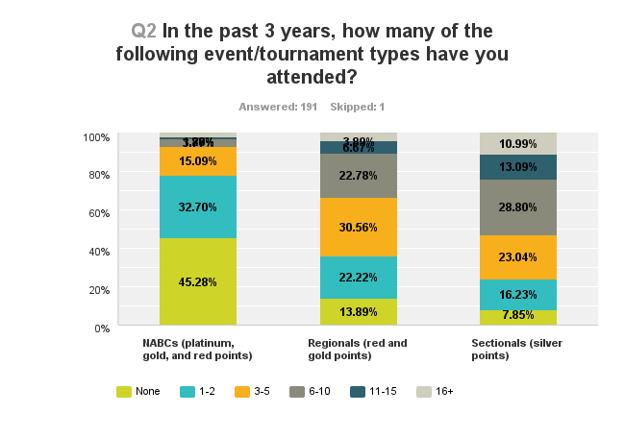
Most players visit club games a few times each week (48%) or a few times each month (32%). Online ACBL tournaments attract 14% to play at least a few times each month; 25% play an online tournament at least once a year. Casual games, in person or online, were far less frequent than any type of ACBL sanctioned event for respondents. (See chart on next page)
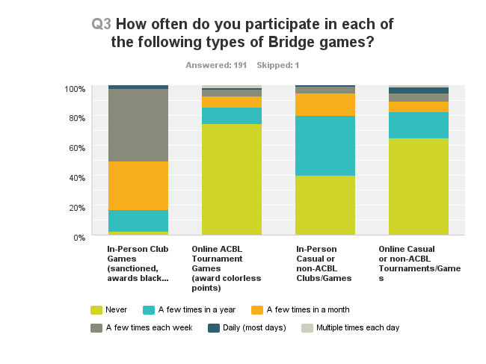

Responses
The geographic location of a sectional is the most important factor in determining if a player will attend, with locations along I-405 (Eastside) preferred by the majority of respondents. (Locations other than Eastside scored roughly equally, with a slightly lower score for Downtown/Central Seattle vs. other location options. Location options included Downtown, Eastside, North Seattle, Northern Suburbs, Southern Suburbs, West Seattle, and South Seattle.) Of the locations used by the unit so far, all scored nearly equally. However, 9 respondents specifically called out an aversion to Vasa Park in comments. No other location was singled out as consistently in comments, positively or negatively.
The other high-scoring factors affecting attendance include (rank order, most to least):
- Whether friends or regular partners can attend
- Types of events offered
- Facilities of event
- Event start times
- Experience I had at last sectional
Of the events we surveyed, offering stratified pairs garnered the most interest. 49er, 299er, etc. limited events and stratiflighted pairs tied for second highest interest. Swiss teams, KO teams, and 2-session matchpoint pairs were also highly rated. For newer players, Pro-Am pairs also stood out with high interest. Individuals, BAM teams, and barometer were the most disliked event types.
For sessions, a session offering stratiflighted pairs with no competing event was the highest ranked. Second was a session offering a team event with or without a side pairs event.
58% of respondents prefer a 10 & 3 start time. 33% prefer 1 & 6:30 start time. 8 respondents noted in comments that making it to a 6:30pm start time after work is tough, and they’d prefer a 7pm or later start time on weekday evenings. For holiday vs. non-holiday weekends, 57% did not have a preference. 33% preferred a non-holiday weekend.
We received largely positive feedback on our sectionals in the open comments. More details and findings from the survey will be provided via email to the board as they are available.

