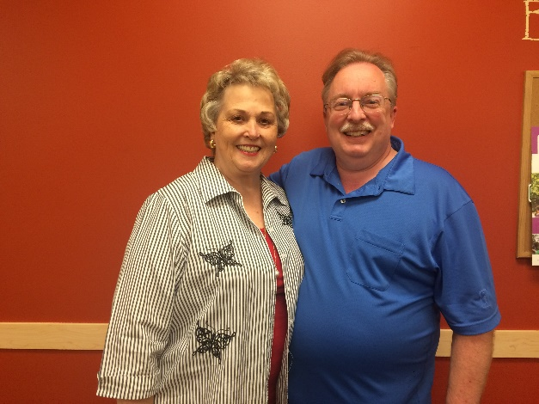

Unit 446 Barometer Pairs

MPs A B C Names Score

3.79 1 Dave Grubbs & Barbara Nist 66.41%
2.84 2 1 Marty Jeide & Dannis Duryea 59.49%
1.43 2 1 Karen Hudesman & Don Stark 56.14%
1.02 2 Eric Sieg & Lak Lakshmanan 55.26%

A great time was had by all at the unit’s Barometer Pairs game on May 1st. Congratulations to Dave Grubbs and Barbara Nist, who won with a whopping 66% game! The Unit Board would like to thank everyone who came out and supported this Unit event (16 tables!). Also a big thank you to ESBC for hosting and to Roger Putnam for directing!

The second of three Trifecta games this year will be a Fast Pairs on Sunday, September 11th at 6:00 pm at Seattle Bridge Club. Fast Pairs allows 5 minutes per board instead of the usual 7-8 minutes, so you are sure to get home early! Hope to see you there!

And remember, the winner(s) of the most total masterpoints from the three games combined will be crowned the overall Trifecta champion!
—Kim Eng

Captain’s Game coming June 5th!
The Seattle Unit is bringing back the very popular captain’s game. Some of the best players in the unit are chosen as captains. They will pick their team from all of the players who sign up (behind closed doors). Once the teams are formed, the format will be Swiss Teams, but you get to play one round with each person on your team. To register, please email Kim at keng@forestridge.org. The deadline to sign up is Friday, June 3rd. This game will be held at ESBC with a start time of 1:00pm. The Seattle Unit will provide light hospitality starting around 12:15pm.

-Kim Eng (Competitions)

