Candidacy statement

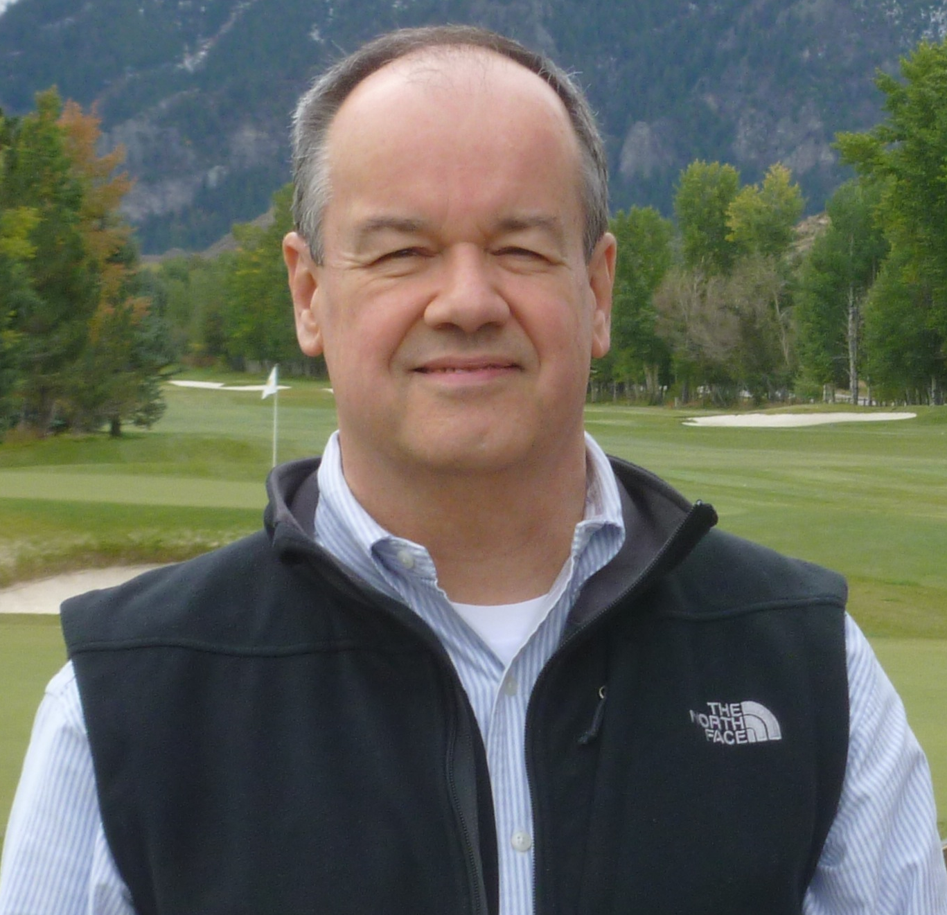

I’m Tim White and I’m running for re-election to the Seattle Bridge Unit 446 Board of Directors. The past three years on the Board have been enlightening and fulfilling. While serving as Treasurer, in addition to day-to-day and regulatory financial duties, I conducted analyses to aid Board decision making involving the Unit’s revenues & expenditures. I surveyed financial institutions and placed the Unit’s accounts with a firm offering better terms. I’m presently Chairman of the Board’s Tournament Sites Committee that is identifying tournament venues that will be more suitable and affordable, and offer greater geographic diversity. Running successful tournaments means having folks serve as tournament chair, as well as setting up & tearing down at the venue, and running errands; I enjoy pitching in on these activities. I hope to serve our bridge community for a second term and ask for your support.

